**A detailed report regarding my system development and functionality with supporting screen dumps:**

I have developed a system which is Inventory Management System based on the CRUD application.

An Inventory Management System is the process by which a person tracks his goods throughout the entire supply chain, from purchasing to production to end sales.

When a user will enter the inventory management system, he will see the index page.



When the user will press the let’s go button, the system will ask which type of user he is.

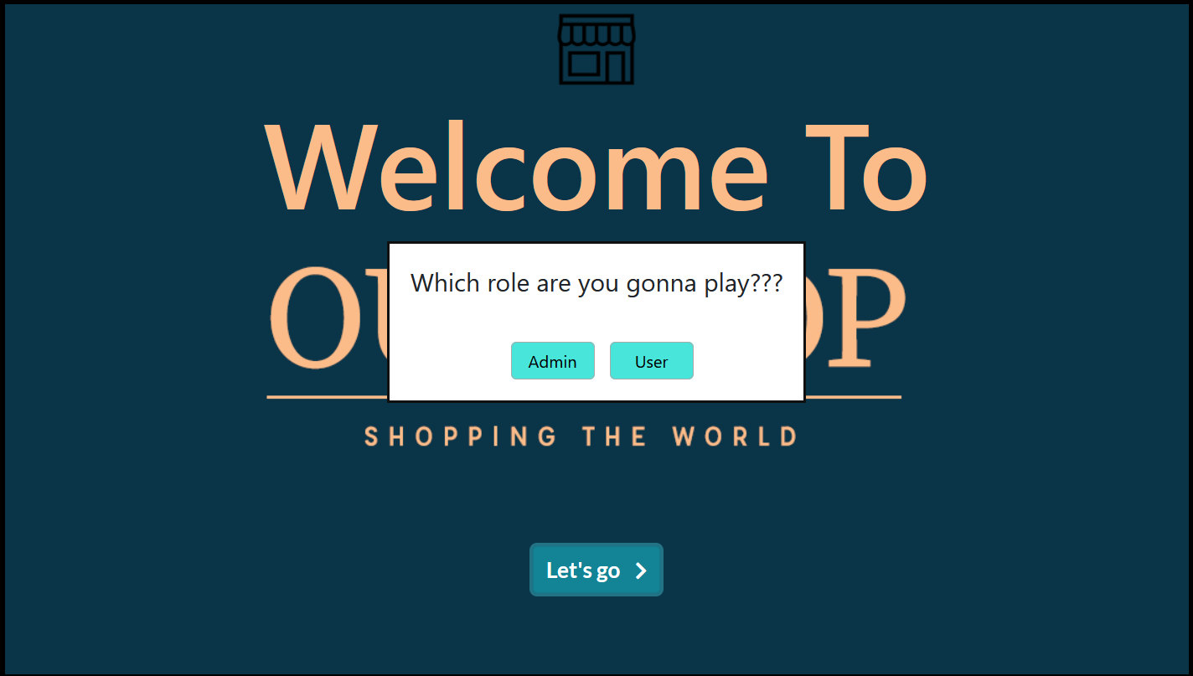

1. If the user selects the admin option, the system will ask for the admin user name and password which is predefined for the admin.

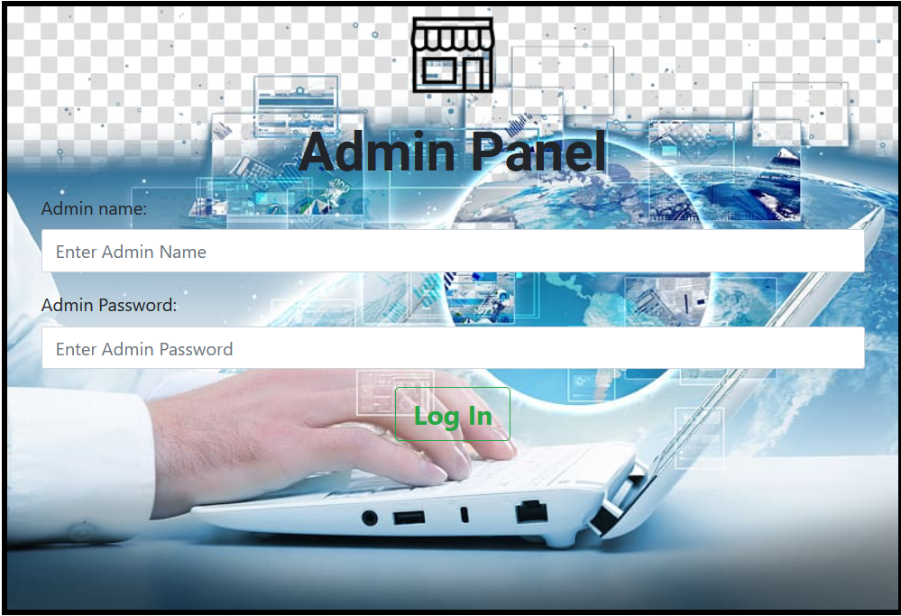

After providing the name and password, and pressing the login button admin will be able to enter the admin menu.

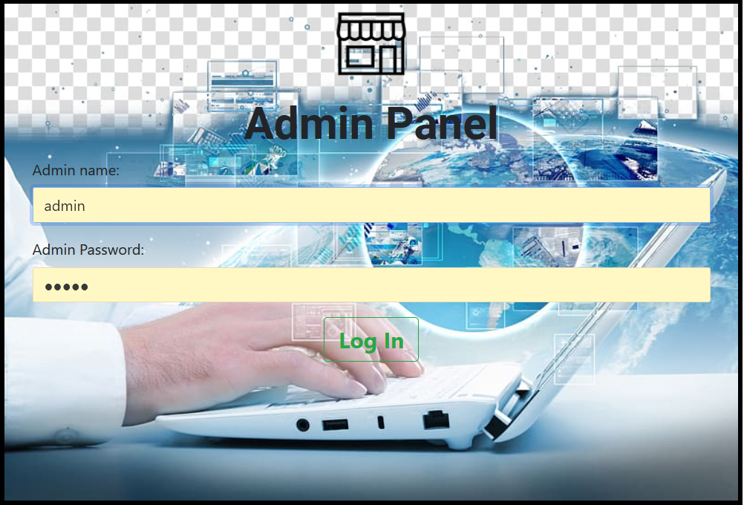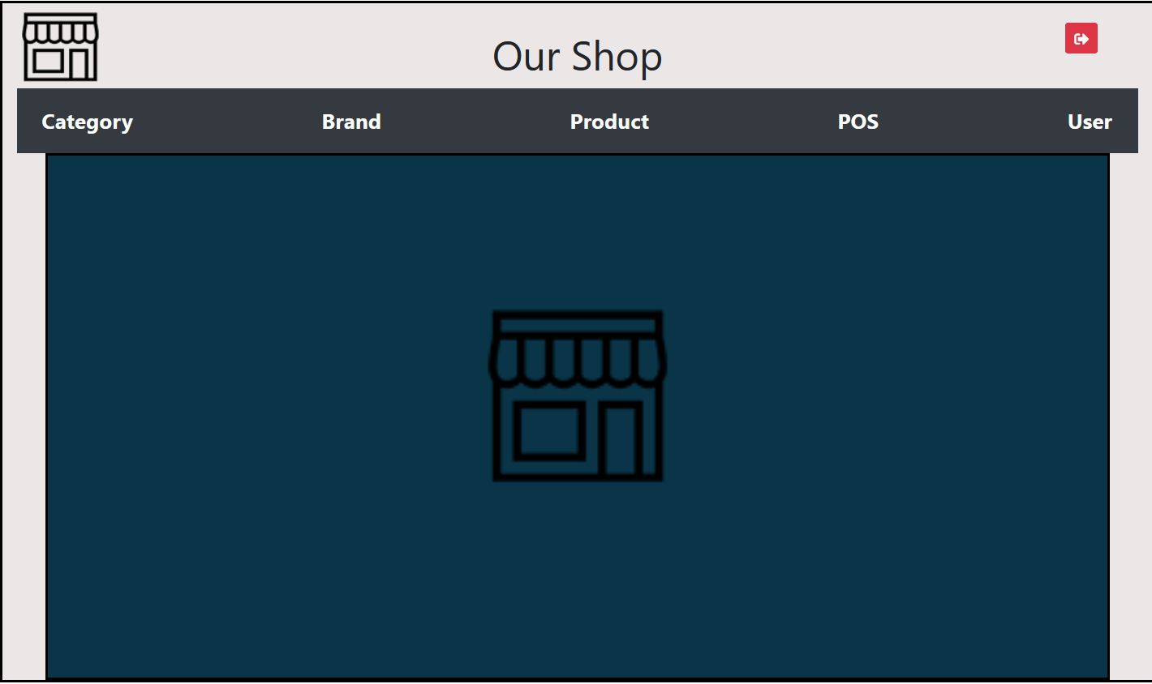

At the top right corner, the red button is for logging out from this system.

If the admin selects an option from the navigation bar, he will be able to go to the selected page.

On the category page, Admin will be able to add category name and status which is the product is in stock or out of stock. After adding the product, he will be able to update and delete the product according to his choice. The right-side table will show the product category instantly.

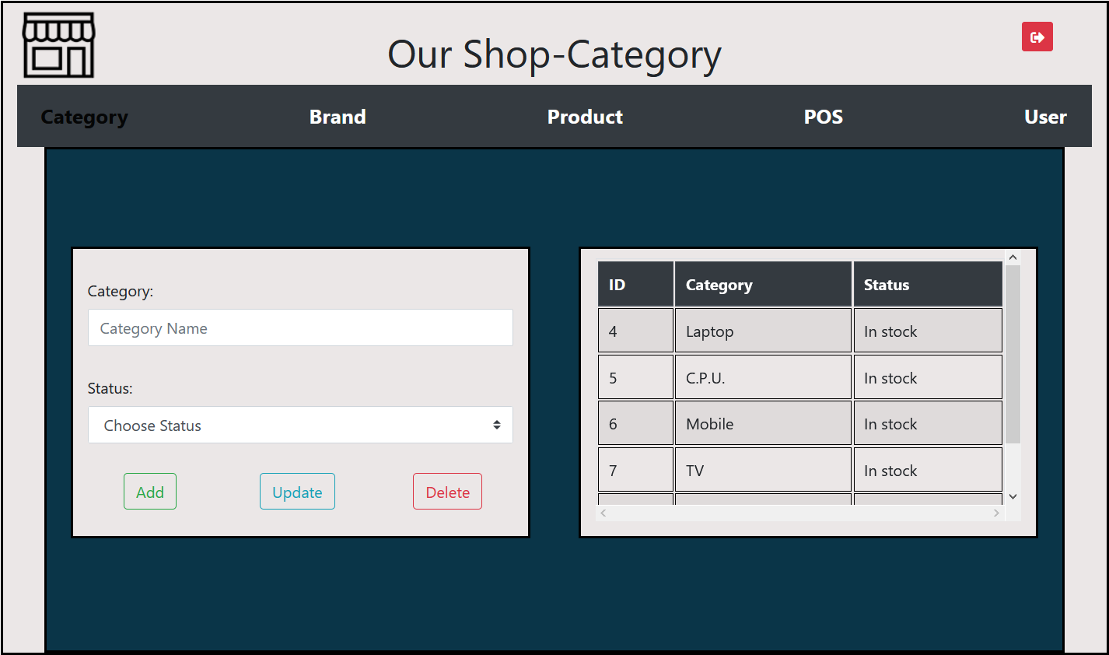

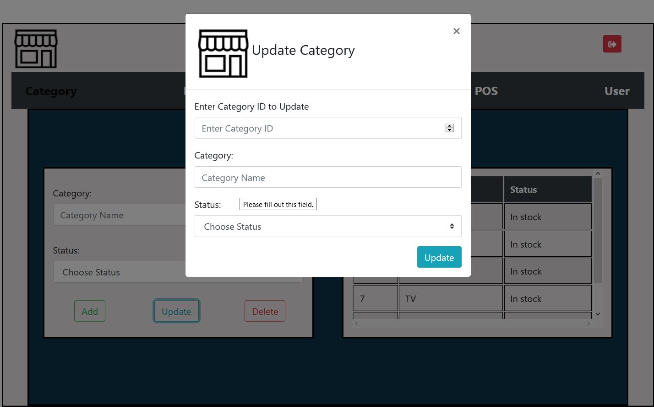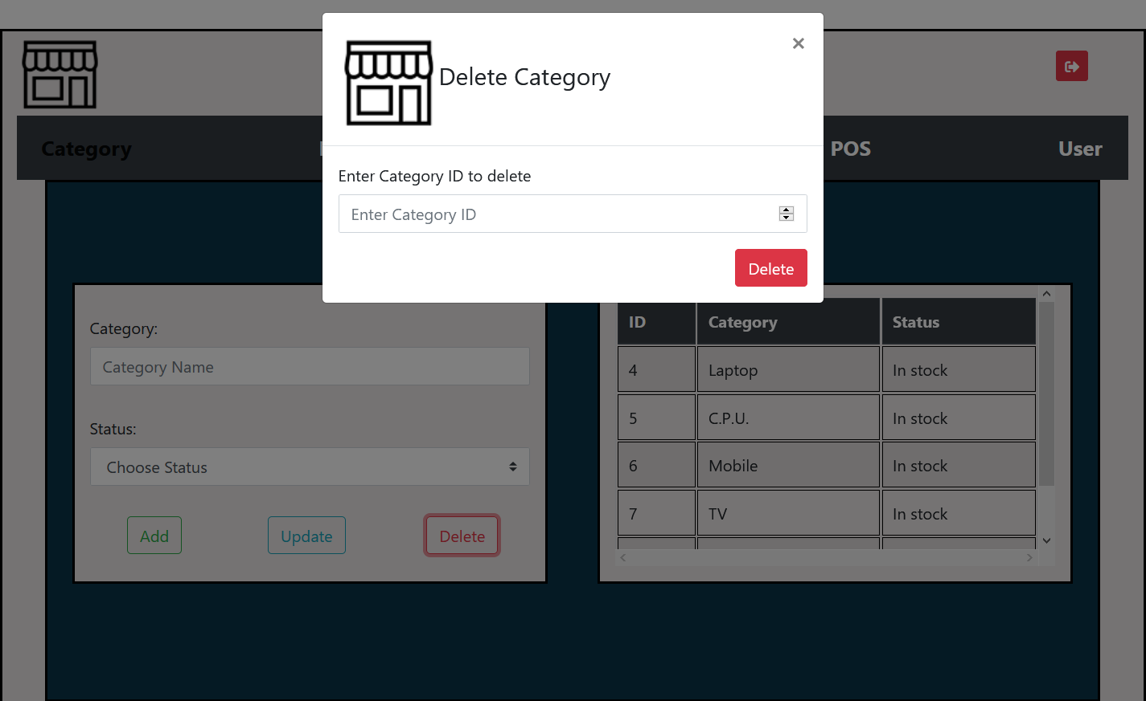

On the brand page, the admin will able to do the same thing for a brand that he has done on the category page.

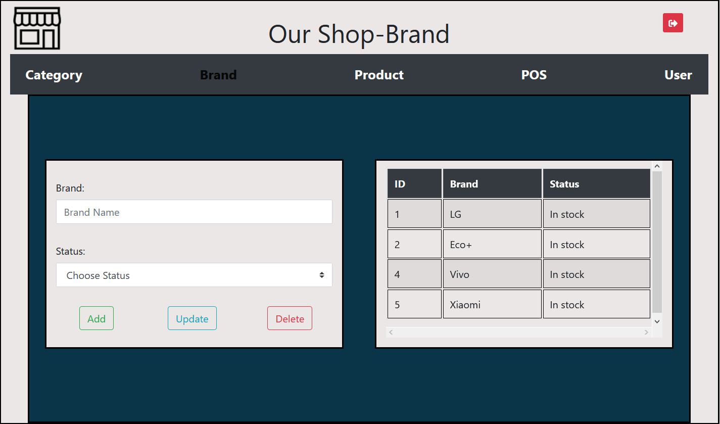

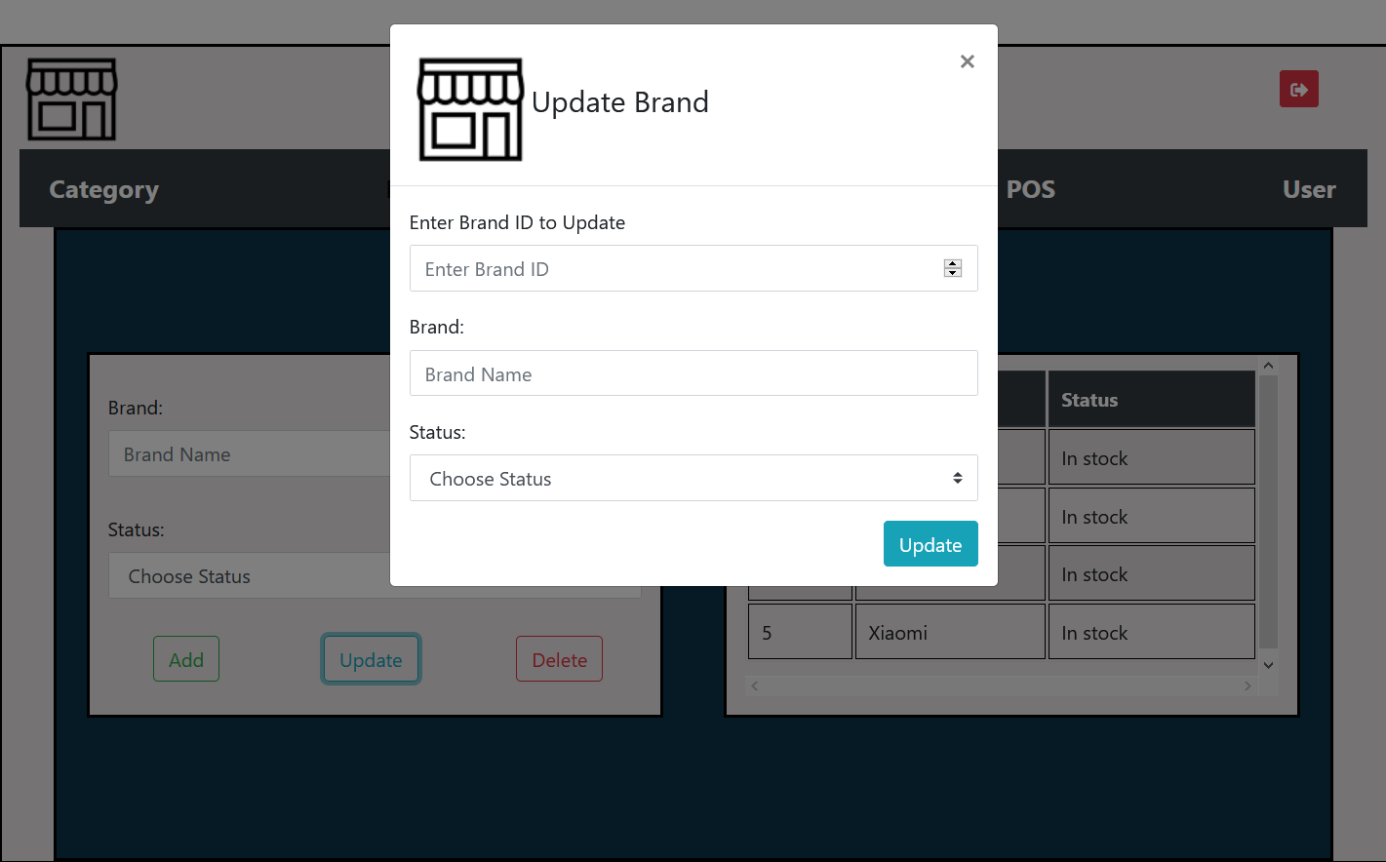

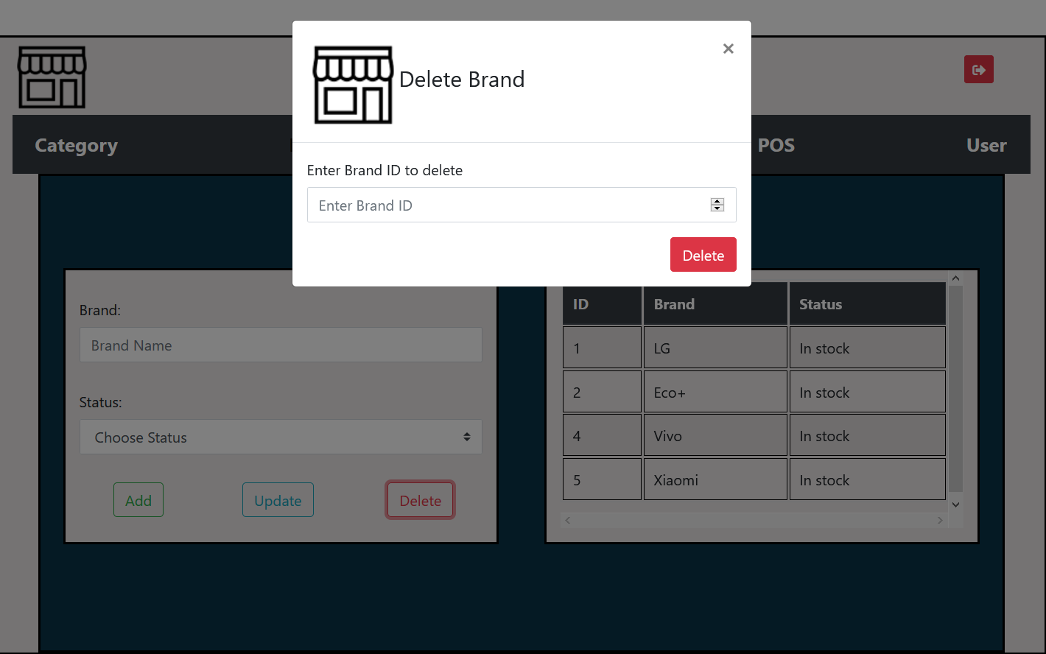

On the product page, the system will ask for the required information. After providing all the information admin able to add products to their stock. For knowing easily, how many products they have, the product list will show in the bottom table. If the admin wants, he can update and delete the product from the stock.

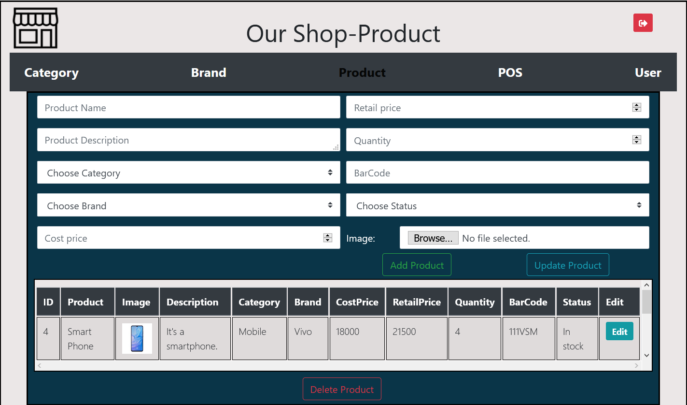

In the Inventory Management System, there is a page that is POS means point of sale. This page is developed so that the admin can sell products from this page. On this page, firstly the admin will be asked for a product bar code, if he provides the valid barcode and press enter the product name and the price will automatically show in the next to input field. Then the system will ask for the quantity that the user wants to take. After providing information and pressing the add product button the product will be added to the product cart. And the number of quantity will be reduced from the product quantity. If the user changes his mind and doesn’t want the selected quantity, he can delete the product, then the quantity will be added to the product quantity again.

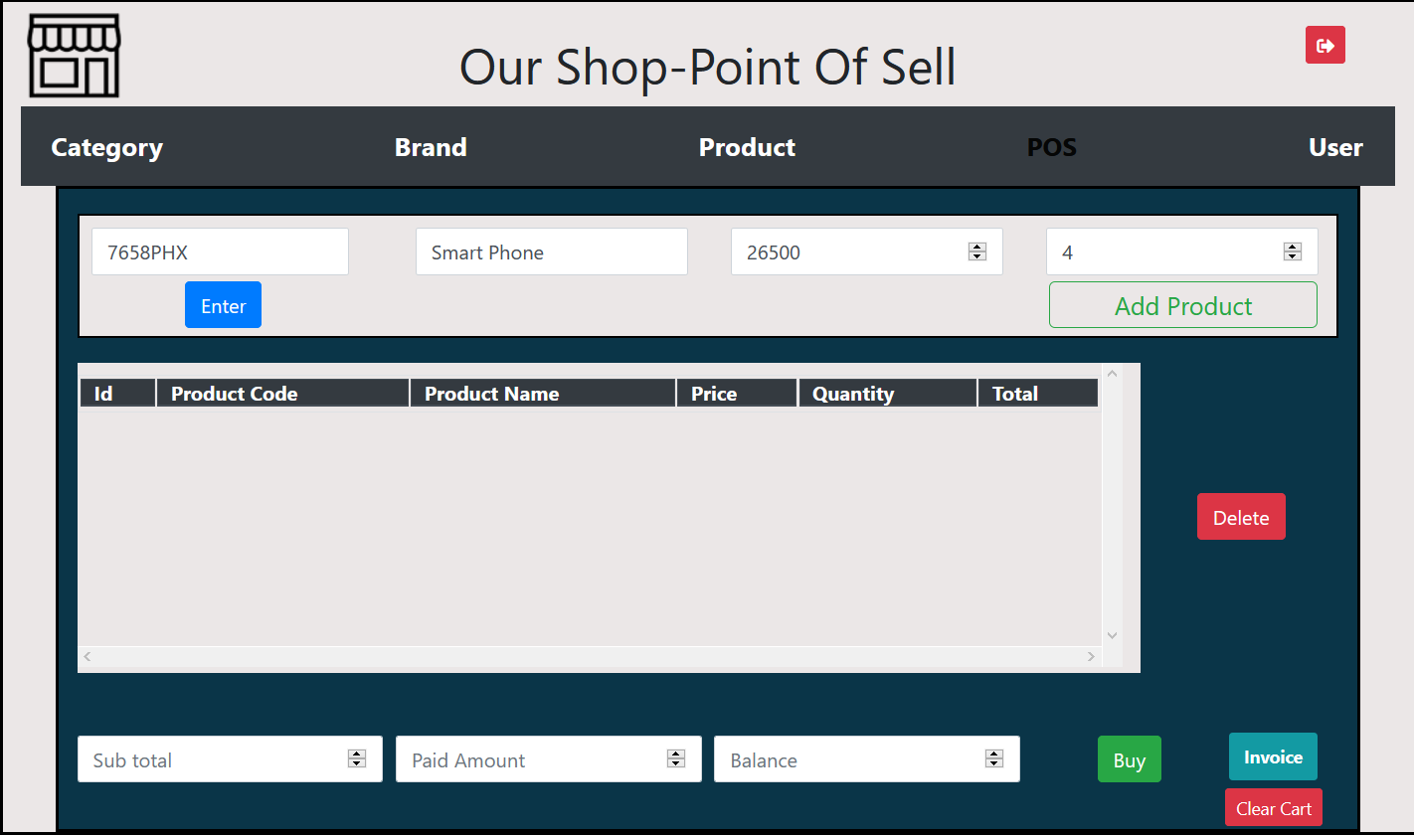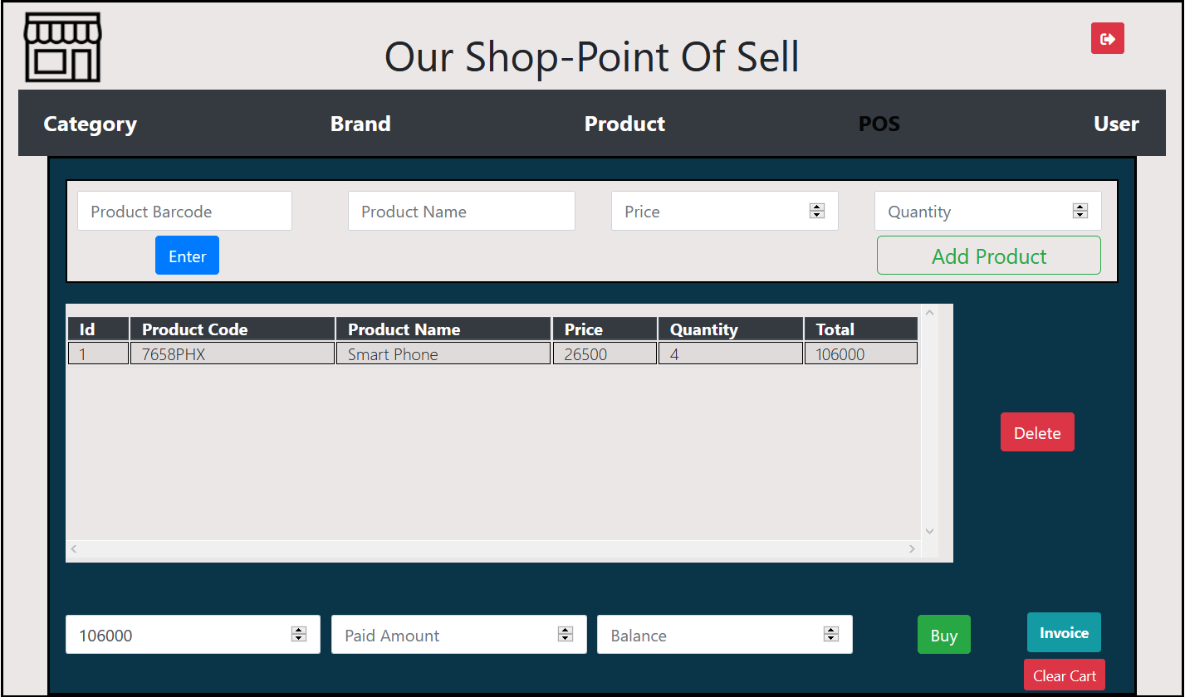

The subtotal price of the selected product will show at the bottom of the page. For buying a product the system will ask for the money if the payment is done and press the buy button, the order will be completed.

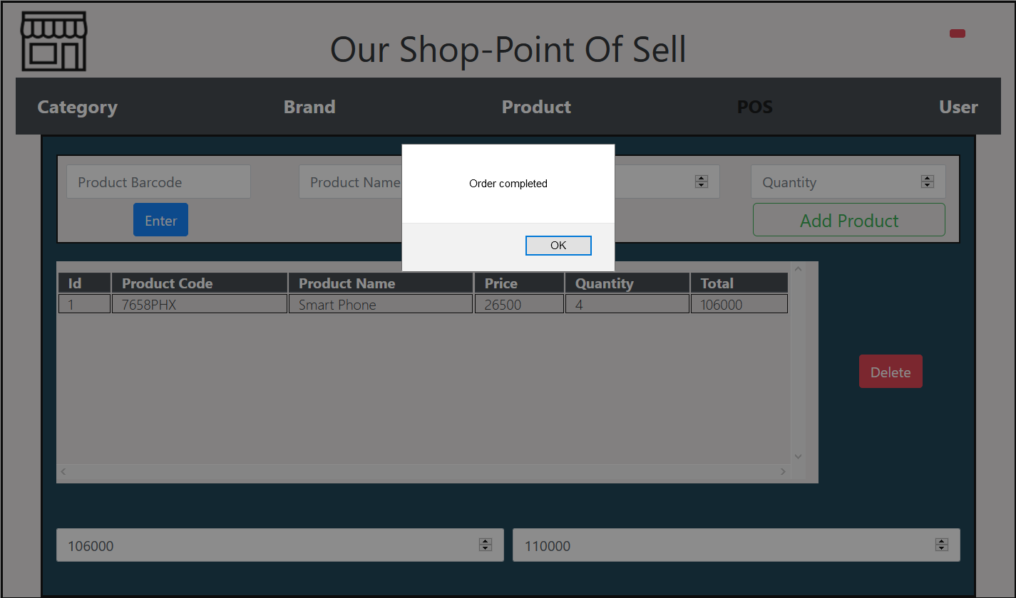

After completing the order, the system will give an invoice by pressing the invoice button.

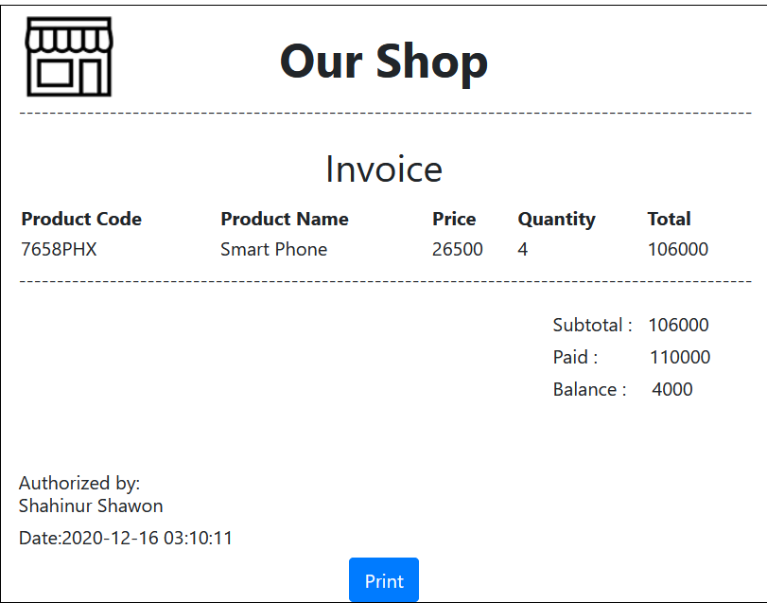

On the invoice page, there is a print button to print the invoice.

After getting the invoice, the admin needs to clear the cart, so he can do it by pressing the clear cart button on the POS page.

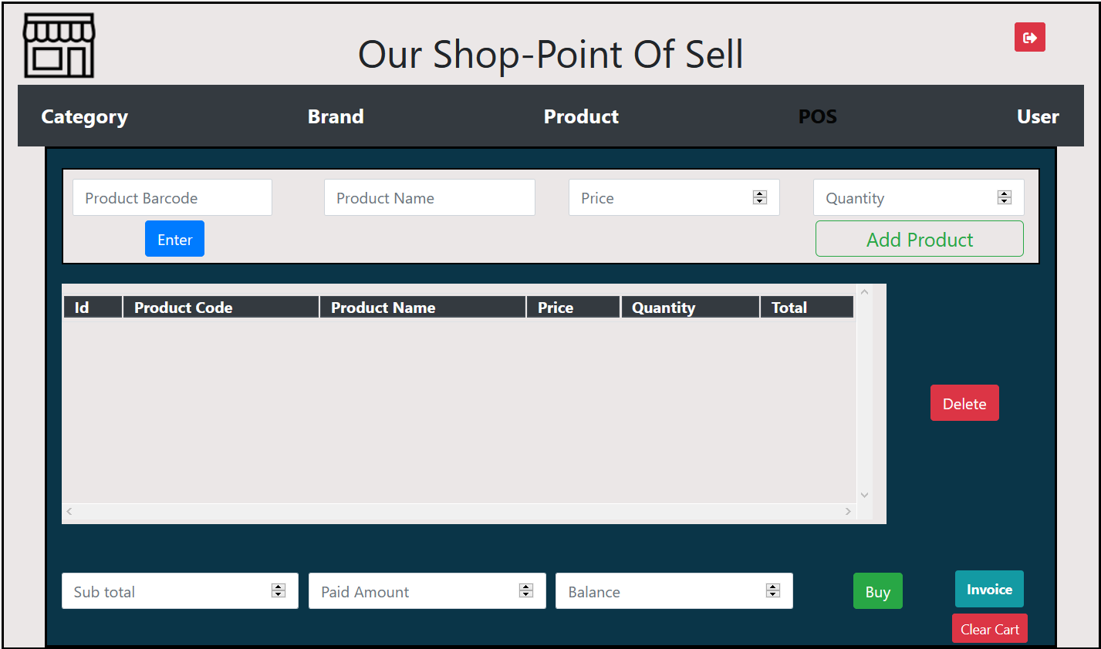

The most important thing, which makes the difference between user and admin that is, the admin will be able to register the user by providing the required information and delete the user, but the user won’t be able to delete any user.

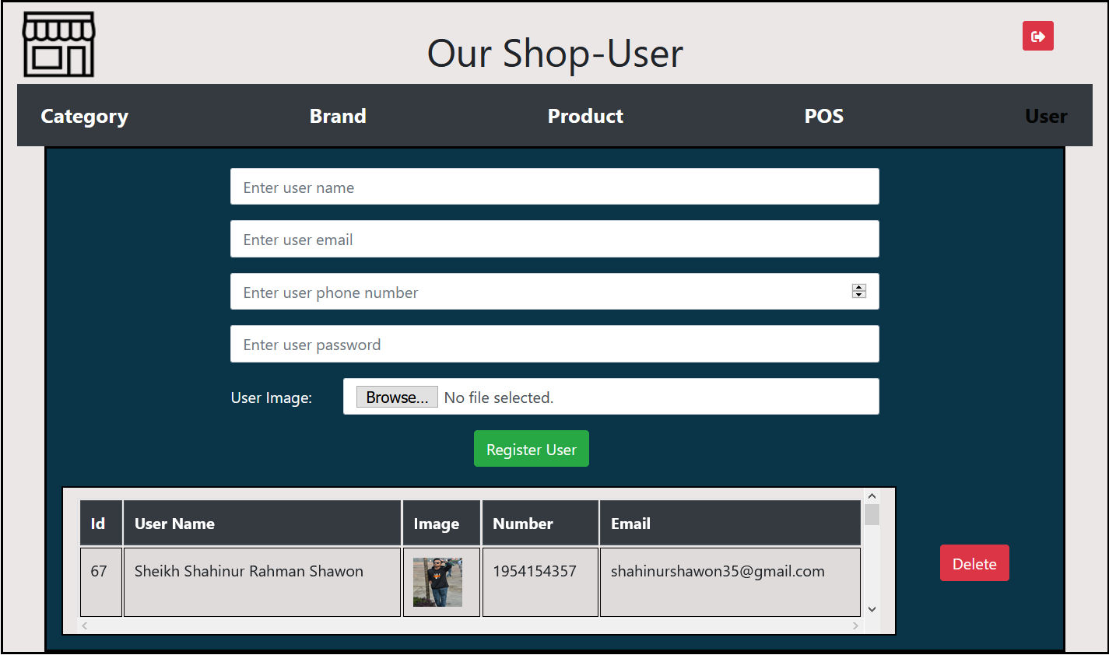

Now if the user selects the user button, he will go to the user login page.



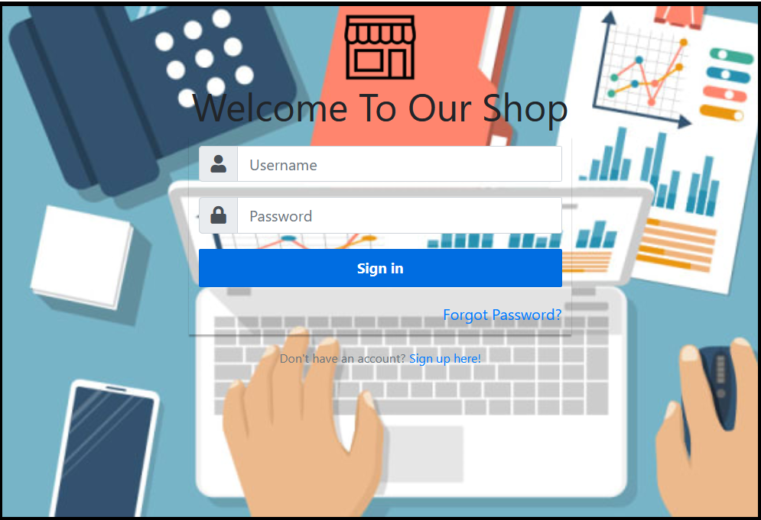

The system will ask the user for the user name and password. If the user is the existing user and forgets his password, there is a forgot password option, by using this option user can recover his password. If the user is new in the system sign-up here option is available for the user.

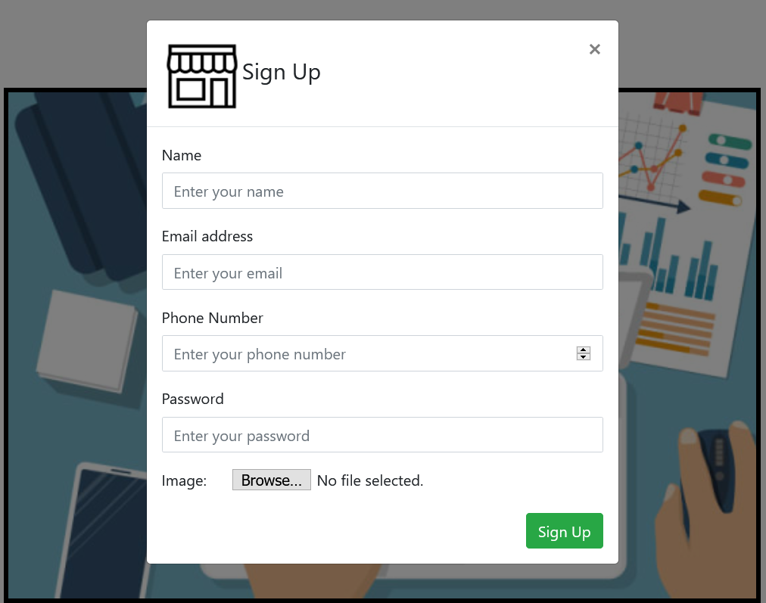

After providing the required information user will be able to register and login into the system. After providing log-in info the user will able to login into the system and the logged-in user name will show in the right top corner.

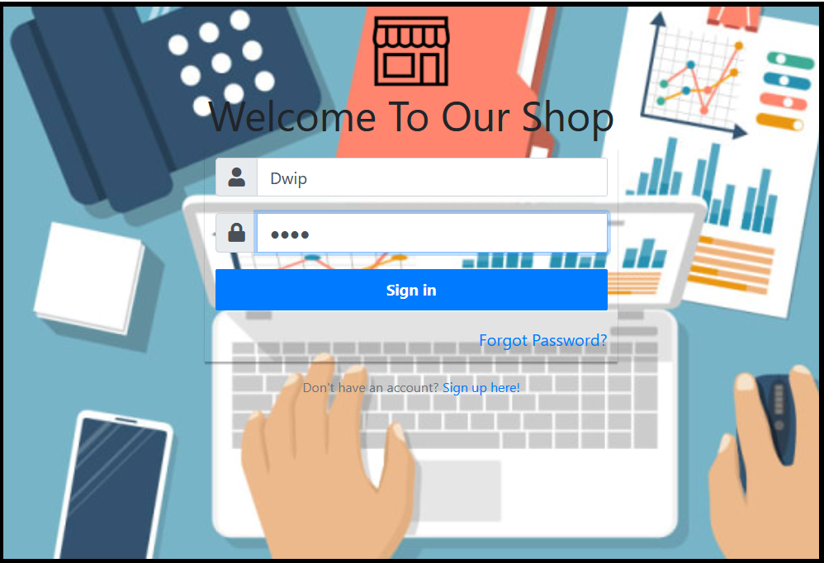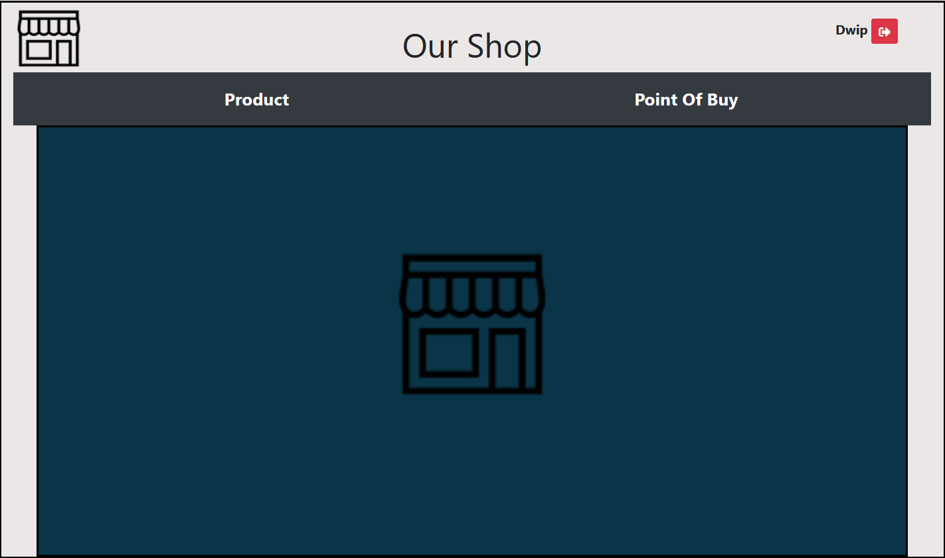

On the product page, the product will show that is available in the shop.

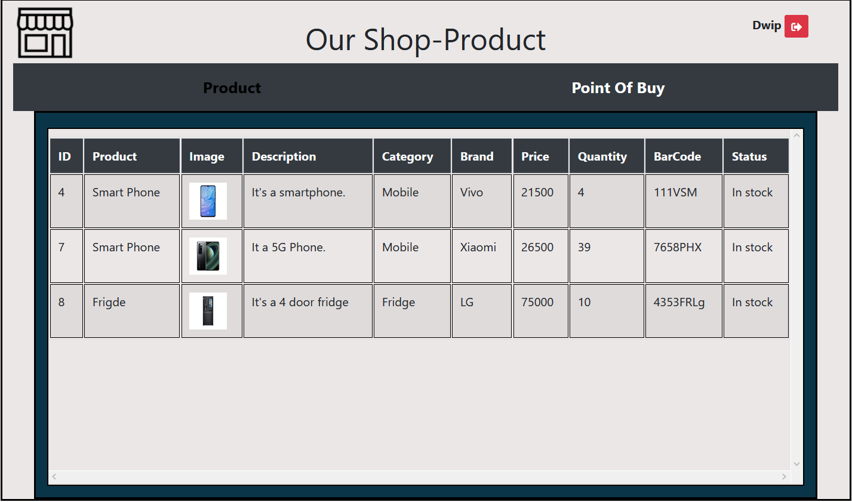

In this system, there is a page which is Point of buy. This page is developed so that the user can buy products from this page. On this page, firstly the user will be asked for a product bar code, if he provides the valid barcode and press enter the product name and the price will automatically show in the next to input field. Then the system will ask for the quantity that the user wants to take. After providing information and pressing the add product button the product will be added to the product cart. And the number of quantities will be reduced from the product quantity. If the user changes his mind and doesn’t want the selected quantity, he can delete the product, then the quantity will be added to the product quantity again.

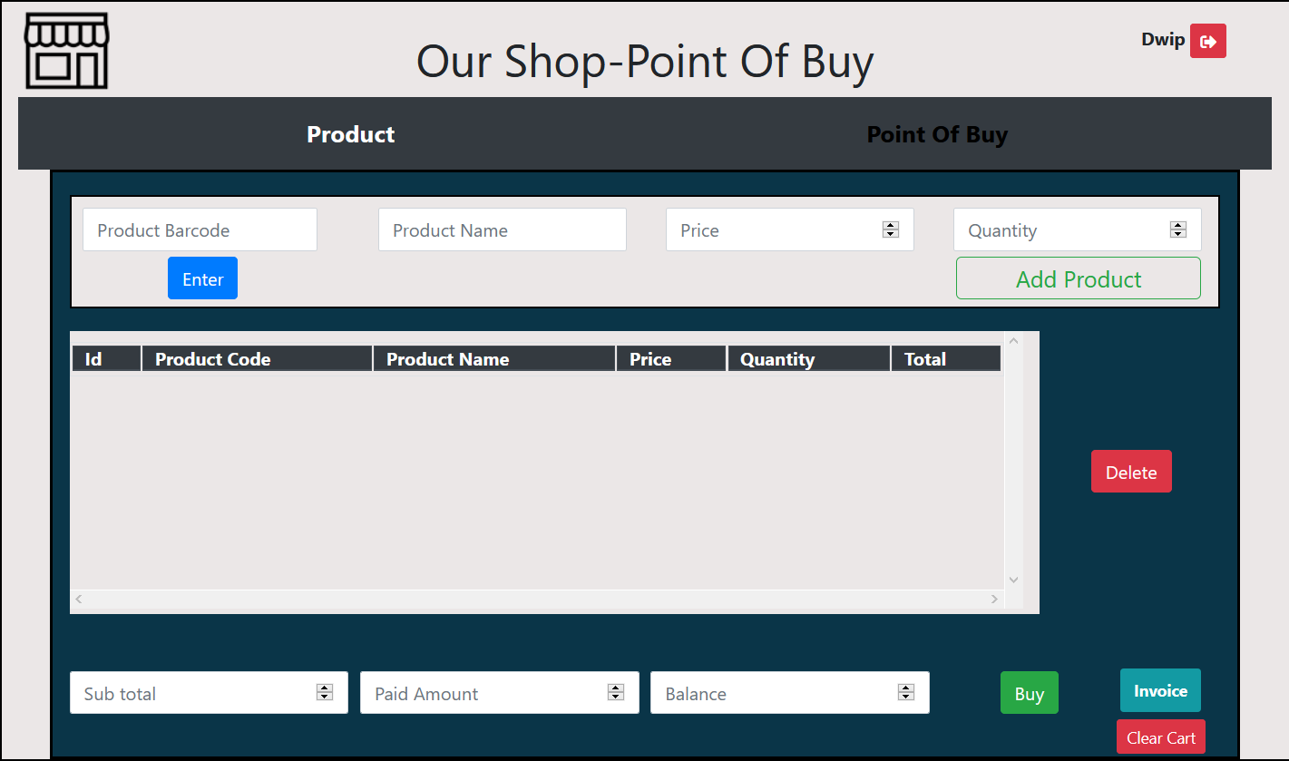

After that, all functionality is the same as what I have done for the admin. The user will buy the product by providing money, then get the invoice and clear the cart.

**Database table and structure that I have used for my system development:**

**The name of the table is in the marked section of the screen dumps.**

